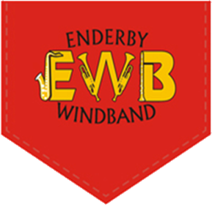
Enderby Wind Band
Music Making Weekend
2nd & 3rd September 2017
Please complete for each person applying for weekend
Personal Details
Name
Address
Telephone Number |  |  | Mobile Number
Email Address
Instruments Played |  |  | Clefs Read
Approximate Grade
Accommodation Requirements
Dietary Requirements
Accessibility requirements
Payment Details | Tick one option
Cheque - £30 per person |  | Please post Cheques to: Charles Kendall, 49 Coventry Road, Broughton Astley, Leicestershire, LE9 6QB
BACS - £30 per person |  | Sort code: 56-00-55 Account Number: 34249842 – please provide suitable unique personal identifier to your BACS payments
Declaration |  |  |  |  | Please Tick
I acknowledge the need for obedience and responsible behaviour on my/my child’s part
This person has read and agreed to abide by the rules
I agree to allow pictures taken to be used as marketing and promotional material – including the use of social media, internet and printed media

Please complete the medical emergency information overleaf
Course Rules
- Participants will remain courteous and respectful towards other players, musical directors and course staff
- Participants will follow instructions issued by musical directors and course staff
- Participants will engage with other players, musical directors and course staff and will enjoy themselves

In Case of Emergency
Name |  | DoB
Surgery Name
Surgery Number
Any medical details likely to be of importance in an emergency e.g. allergies/medication
Emergency Contact Person
Name
Telephone Number
Relationship
Address, if different to that overleaf

Please return the form with suitable method of payment. Forms can either be emailed to enderbywindband@hotmail.co.uk or posted to Aaron Vogel, 19A The Parkway, Leicester, LE5 2BB.
The information contained on this form will be use solely for the purpose of the Music Making Weekend and will not be shared with any other parties.

